Financial Econometrics
Solution Sheet on Problem Set 1
Review of Statistics
Deadline: 11/03/2026
Solved by: Cyril Gabriele, Adriano Lama
Task |  | Points Earned
2) Calculate the monthly logarithmic returns of SP500, STOXX600, NIKKEI, GOLD and WTI. Convert the risk-free rate to monthly values. Subsample your data to start in January 2005. Report the mean logarithmic return for STOXX600 and NIKKEI. (2 points) | Mean monthly log return STOXX600: 0.0033  Mean monthly log return NIKKEI: 0.0053  Note: Subsampled starting January 2011 as instructed in the PDF.
3) In separate graphs, plot the time series of the WTI price index and of WTI returns. Comment briefly on any striking feature of the return series. (1 point) | WTI returns show a spike of -78.19% around Mar 2020, highlighting the volatility. The year 2020 was the year of the pandemic, where the oil prices crashed.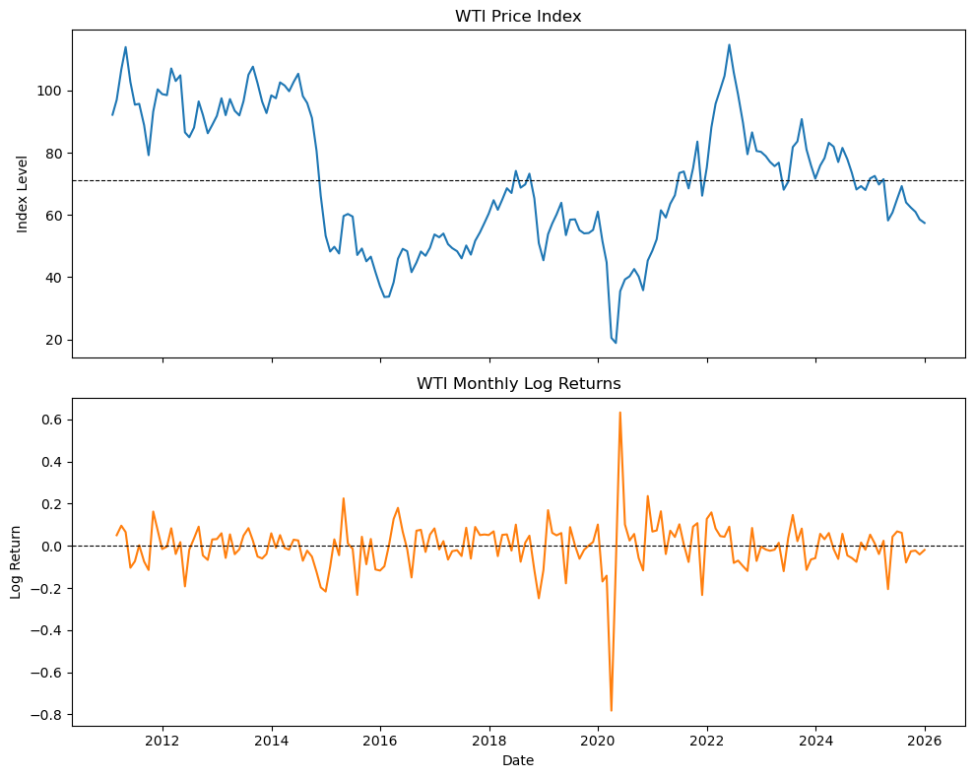
4) Test the null hypothesis that the average monthly return of STOXX600 is significantly different from zero at the 5% level. Report the t-statistic and whether you reject or cannot reject the null. (2 points) | t-statistic: 0.9994  p-value: 0.3190  FAILED TO REJECT H_0
5) Calculate the 95% confidence interval around the mean return of GOLD. Can you be 95% sure that GOLD has been a better investment (in terms of average return) than the risk-free rate over this period? (2 points) | 95% CI lower bound: -0.0004  95% CI upper bound: 0.0128  Average monthly risk-free rate: 0.0021  Cannot claim Gold outperformed the risk-free rate at the 95% confidence level.
6) Calculate the correlation matrix of the five risky assets’ returns. With which asset are WTI and SP500 most correlated, respectively? Does any correlation coefficient surprise you? (2 point) | WTI most correlated with: STOXX600_monthly_log_return (r= 0.44)  SP500 most correlated with: STOXX600_monthly_log_return (r=0.82)  It’s surprising, that WTI’s strongest correlation is with European equities (r=0.44) rather than US ones (r=0.40), given that the WTI is a US-based commodity.
7) Among the five risky assets, report the asset with the highest excess kurtosis and the corresponding coefficient. Plot a histogram for this asset’s returns, overlaying a fitted normal distribution. Is the return distribution approximately normal? (2 point) | Highest excess kurtosis: WTI_monthly_log_return = 15.7320  The distribution is not approximately normal. The histogram has heavier tails and a sharper peak than the normal distribution.  Statistically, the excess kurtosis is 15.73. The excess kurtosis of a normal distribution should be 0. Our value is very high, probably due to the spike of -78.19% around Mar 2020.  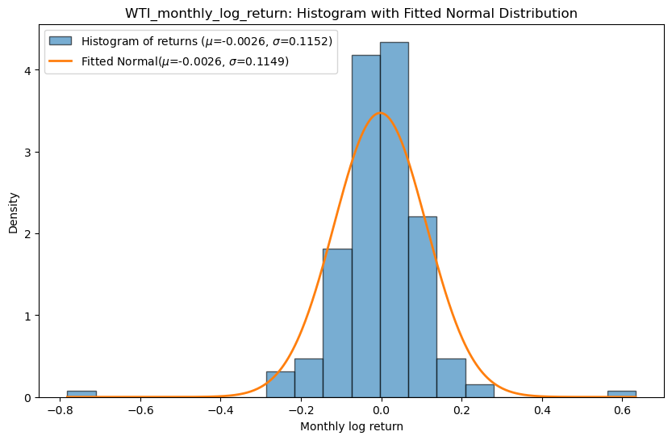
8) Report which of the five risky assets is farthest from a normal distribution according to the Jarque-Bera test. Report the test statistic and p-value. (1 point) | Farthest from normal: WTI_monthly_log_return  JB statistic: 1772.8998, p-value ≈ 0.000  Because the p-value is approximately 0, we strongly reject the null hypothesis.
9a) Report the number of rate hike months in your sample. (2 points) | Total hiking-cycle months (sum of D_t): 43
9b) Add SPDIV/12 to the SP500 index level and divide by the lagged index level to construct the total return series. Report its standard deviation. (1 point) | Std Dev of SP500 Total Return: 0.0435
9c) Select only the months classified as hiking-cycle months. Calculate the average total return of SP500 and its interquartile range during these periods. (2 points) | Hiking Cycles -> Mean: 0.0218, IQR: 0.0327
9d) Repeat the same exercise for months outside a hiking cycle (easing/pause months). (1 point) | Easing/Pause Cycles -> Mean: 0.0278, IQR: 0.0542
9e) Assume that the two underlying populations have equal variance. Use the t-test function of R to perform a two-sample t-test (not a paired one), comparing the two means:  H0 :μhike =μease  Report the t-statistic, the p-value, and interpret the result. Are average returns during hiking and easing cycles significantly different at the 5% level? Does the sign of the difference align with your prior expectation? (2 points) | t-test -> t-statistic: -0.7986, p-value: 0.4254  Result: Fail to reject H_0 at the 5% level. There is no statistically significant difference in average total returns between hiking and easying months.  We expected lowr returns during hiking cycles due to tightening financial conditions. The sign of the difference is consistent with this. Hiking returns (0.0218) are lower than easing returns (0.0278), yielding a negative t-statistic. However, the difference is not statistically significant, so we cannot draw a firm conclusion.

